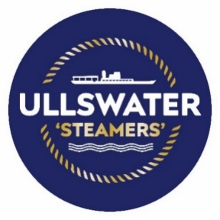
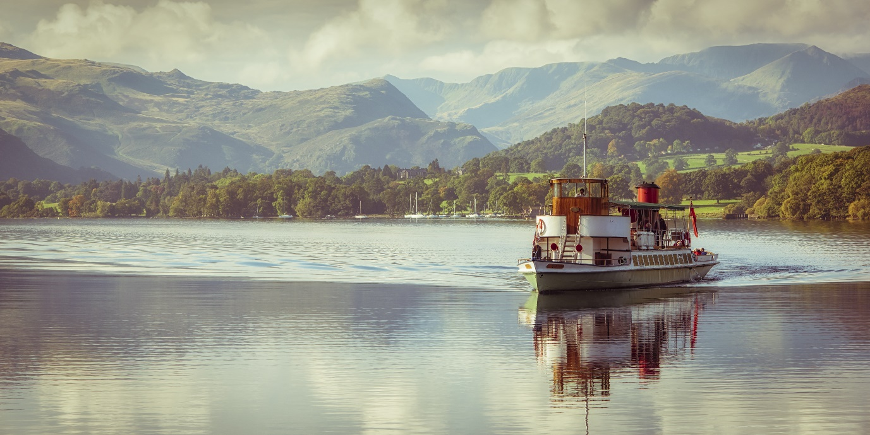
M.Y Raven back in ship-shape!
Ullswater ‘Steamers’ complete preservation project on second oldest vessel
One of the Ullswater ‘Steamers’ iconic heritage boats has been revived, as the 133-year-old ‘M.Y Raven’ has been fitted with a brand-new deck during a significant restoration project.
Raven has been cruising the length of Ullswater in the Lake District since 1889, as one of the original ships of the Ullswater Navigation and Transit Company which was used to transport goods, mail, and passengers.
Listed on the National Historic Ships register, M.Y Raven was originally built as a steam vessel but was eventually converted to diesel powered Cumming Engines in the 1930’s.
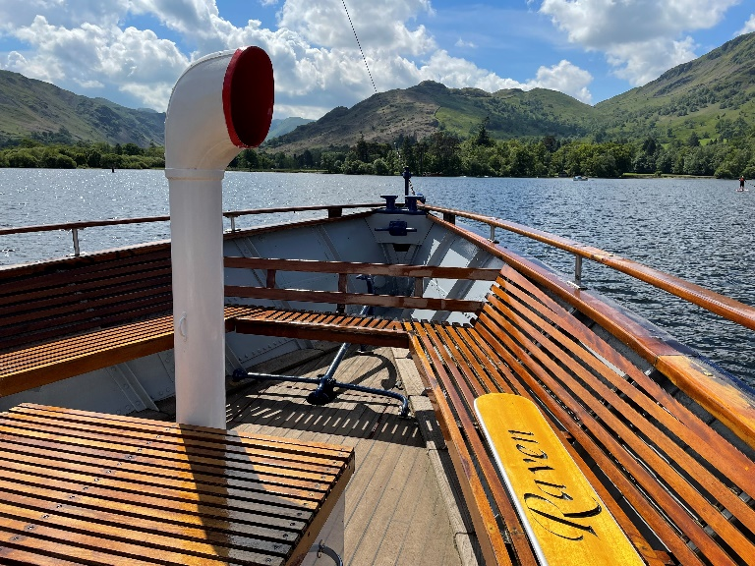
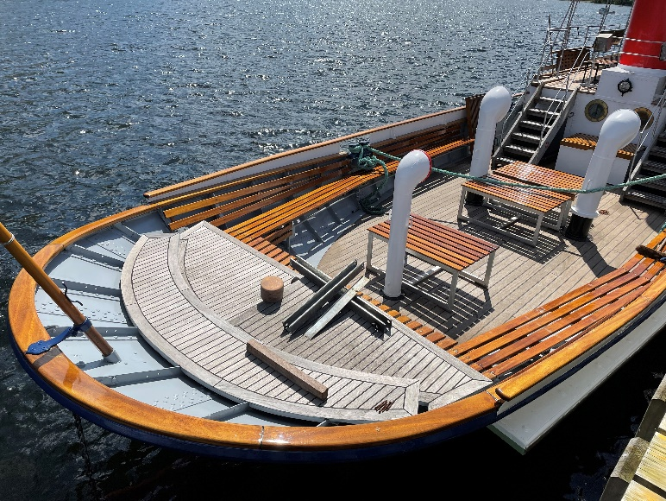
Now visitors for years to come will still be able to enjoy Raven, thanks to the recent completion of large restoration project led by Hamish Patterson of Patterson Boat Works, to lovingly restore her back to ship-shape.
Hamish worked alongside the team at Ullswater Steamers to replace the upper decks with 70 square-metres of sustainably sourced Iroko. Meanwhile her saloon has been refitted with American Light Oak, with the whole project being proudly finished to a first-class yacht standard.
Barry Crellin, Engineer at the Ullswater Steamers says, “Raven has been brought back to her former glory, the whole team worked really hard to finish this project to a high standard and the results are superb! There is so much history in these vessels and projects like this ensure we are protecting the rich 160-year history of the Steamers so they can enjoyed by visitors for years to come.”
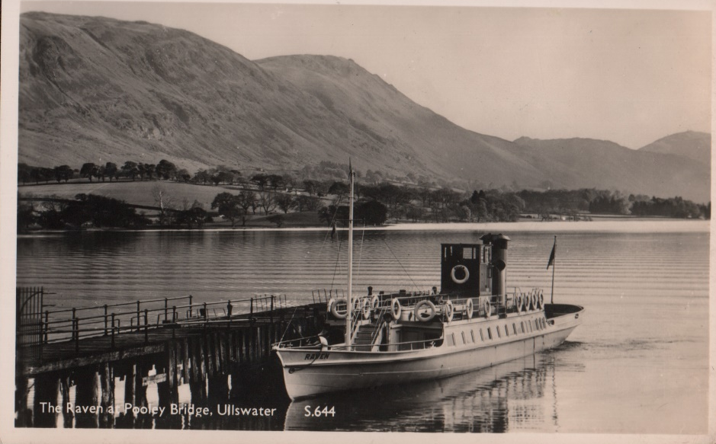
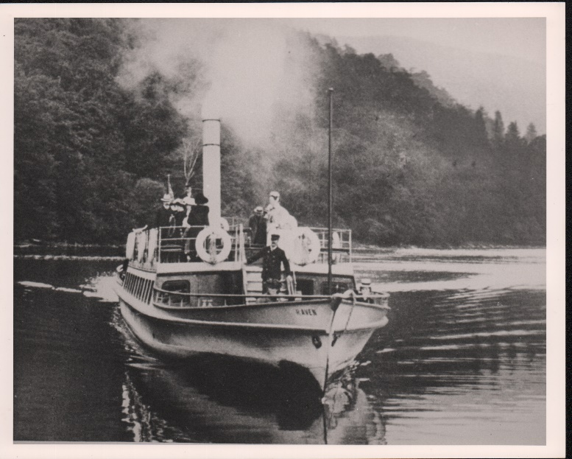
Raven is back out on the water now and passengers can sit back and relax from onboard, whilst enjoying the spectacular views across the Ullswater valley.
Raven was officially added to the Steamers fleet on 16 July 1889 after identifying a need for a second boat during the peak holiday seasons. She was built on the Clyde and delivered in sections by train to Penrith before being transported by horse and cart to Pooley Bridge.
She was christened ‘Raven’ by Miss Winifred Parkin, aged 6 – legend has it the younger the person that names a boat – the longer she will live! Which is certainly the case for Raven who is still cruising across Ullswater almost 133 years later.
ENDS
Notes to Editors:
For media enquiries or interview requests, please contact Holly Collins, Cumbria Tourism Bespoke PR – hcollins@cumbriatourism.org / 01539 822222
About Ullswater ‘Steamers’
Ullswater ‘Steamers’ is a family-owned business that has been operating in the tranquil Ullswater Valley since 1859. Today, the company provides a sustainable and environmentally friendly way of linking some of the most iconic walking routes and views in the Lake District National Park. Ullswater ‘Steamers’ has one of the largest heritage passenger vessel fleets in England, including the oldest working passenger vessel in the world, Lady of the Lake.

